.

HEE LaSE Short Duration (Taster) Placements for Trainee Pharmacists

Hospital Pharmacy Workbook

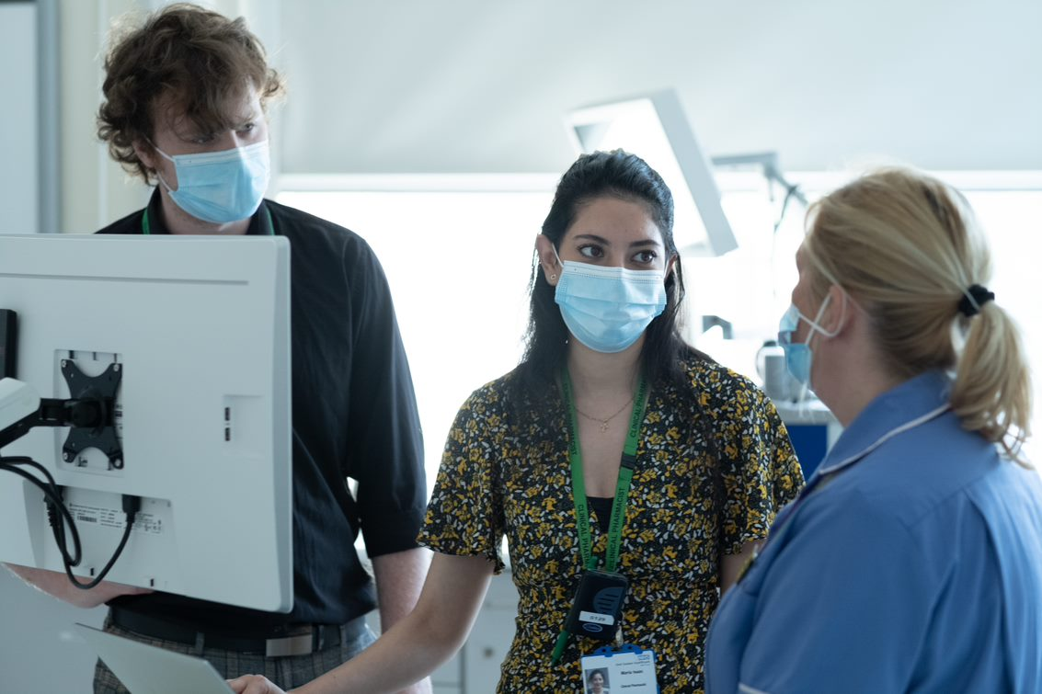
Foundation Training Year 2022/ 2023

Supporting educational training partnerships and cross-sector training development between pharmacy sectors

Contents of the Hospital Pharmacy Workbook
This short duration (Taster) placement hospital pharmacy workbook should be used in conjunction with the HEE LaSE Short Duration (Taster) Placements for Trainee Pharmacists Guide. It has been created to enhance your experience and help you to maximise opportunities from your short duration placement in hospital pharmacy. It is recommended that you work through this workbook with your placement supervisor and your Designated Supervisor (as required).
Trainee Pharmacists (TPs) should use this workbook to identify their learning needs, refer to suggested learning resources and activities, and to map their evidence to the GPhC Interim Learning Outcomes for Foundation Training Year to save to their portfolio or upload to their HEE e-portfolio. TPs should also link this evidence to their Personal Development Plan (PDP).

This workbook is divided into 3 sections:
- Section A: Trainee Pharmacist Pre- Placement Preparation
- Section B: Resources, activities, and tasks to support you during the placement
- Section C: End of placement activities.

Please refer to the HEE LaSE Short Duration (Taster) Placements for Trainee Pharmacists Guide for:
- Information about placement supervision and Trainee Pharmacist responsibilities during the placement
- Leave arrangements and working hours.
- Pre-placement Preparation guidance including the Trainee Pharmacist Pre-Placement Preparation Checklist

Contents

Contents of the Hospital Pharmacy Workbook 2
Acknowledgements 3

Section A: Pre- Placement Preparation for Hospital Pharmacy Placements 4
1. Placement Learning Objectives 4
2. Placement Activities 6
3. Pre-placement Learning 8
4. Self-assessment Quiz 9

Section B: During the Placement 11
1. Induction Checklist 11
2. Sample Timetable for a 2-week Placement in Hospital Pharmacy 13
3. Placement Resources 15
4. Placement Activities and Topics 16
4.1 Topics to Support Placement Learning 17

Section C: End of Placement 24
1. Reflection 24
2. End of Placement Feedback 24
2.1 End of Short Duration (Taster) Placement - Supervisor Feedback Form 25

Evaluation 26
Further support and points of contact for Short Duration (Taster) placements 26
Glossary & Abbreviations 26

Appendix 1: Additional Resources for further professional development 27
Appendix 2: Accessing e-Learning for Health (e-LfH) 28

Acknowledgements
This workbook has been adapted from the HEE LaSE Trainee Pharmacist Programme Guide for Educational Programme Leads and Designated Supervisors 2022-23, HEE LaSE Foundation Training Year Handbook 2022-23 (available through HEE Moodle).

Section A: Pre- Placement Preparation for Hospital Pharmacy Placements
Please refer to the HEE LaSE Short Duration (Taster) Placements for Trainee Pharmacists Guide for general pre-placement guidance, including the Trainee Pharmacist Pre-Placement Preparation Checklist.

Placement Learning Objectives
You can use the suggested placement objectives in Table 1 below to help you consider your learning objectives for this placement. Bear in mind that not all will be possible to achieve or cover during a short duration placement. The placement supervisor will review the objectives to see which of these suggested objectives can be achieved during the placement.

It is the Trainee Pharmacist’s responsibility to identify their key learning needs and agree these as placement objectives with the placement supervisor before the start of the placement.

Remember!

This is a short introduction to Hospital Pharmacy. It will not be possible to cover all the suggested objectives in Table 1 or all the GPhC learning outcomes you would like to complete during this time.

Table 1: Suggested Placement Learning Objectives that may be included in a Hospital Pharmacy short duration placement
 | Placement supervisor to tick box to indicate included objective. | Include in placement?  (Supervisor) | Date completed (TP)
1 | Demonstrate awareness of the patient’s journey from admission to discharge within a hospital setting and the transfer of medication process between different sectors.
2 | Describe how interface communication occurs at admission and discharge between the hospital pharmacy team and other sectors. Be able to discuss a specific example where this impacted patient care.
3 | Demonstrate awareness of the roles, day to day responsibilities and skill sets of the hospital pharmacy team - please note the below list is not exhaustive:  - Store keeper  - Dispensary manager, Responsible Pharmacist  - Purchasing team  - Clinical pharmacists  - Medicines management and Accuracy Checking technicians  - Pharmacy assistants  - Medicines Information team  - Specialist pharmacists e.g. Formulary, Medication Safety pharmacists  - Aseptics team  - Education and development team  - Chief pharmacist
4 | Describe the role of pharmacy within the multi-professional ward team during meetings such as huddles, handovers and ward rounds. Have an awareness of the importance of leadership, management and collaboration in these settings.
5 | Demonstrate awareness of the role of the prescribing pharmacist within a hospital environment and how their skills benefit the patient journey to understand relevant legislation and clinical governance related to prescribing e.g. specialist pharmacists (pharmacist-led clinics and prescribing at ward level).
6 | Demonstrate awareness of how the IT systems in the hospital support pharmacist activities e.g. medicines optimisation and medicines leadership to improve patient care.
7 | Demonstrate awareness of the process of dispensing, checking, and screening prescriptions within the hospital setting and how this might vary to that in other pharmacy settings.
8 | Describe how medicines information is accessed; whether this is via an in-house team or linked to another organisation, and the process for healthcare professionals to access this service.
9 | Demonstrate awareness of the types of pharmacy queries that may occur during and outside pharmacy opening hours and how these are be managed.
10 | Demonstrate awareness of local and national resources such as Trust guidelines and evidence-based medicine to support delivery of pharmaceutical care to patients.
11 | Describe how hospital pharmacy staff promote public health and raise awareness of healthy lifestyles.
12 | Demonstrate awareness of high-risk drugs (including total parenteral nutrition) as per safety alerts and the GPhC registration assessment framework.
13 | Discuss local clinical governance/risk structures, including how to report errors, incidents and poor practice within the organisation.

Placement Activities
Table 2 lists a range of suggested activities that could be undertaken by a Trainee Pharmacist to enable completion of the chosen placement objectives mapped to the GPhC interim learning outcomes 2022-23.

You can map evidence from your placement activities and tasks to these and save them in your portfolio or upload to your HEE e -portfolio.

Table 2: Potential placement activities in Hospital Pharmacy mapped to the GPhC Interim Learning Outcomes 2022-23 and Short Duration (Taster) Placement Objectives
(Adapted from HEE LaSE Trainee Pharmacists Handbook 2022-23)
Non-Patient Facing Activities | GPhC Learning Outcomes | Taster Placement Objectives
Outline the day-to-day responsibilities and skill sets of the hospital pharmacy team | 46 | 1, 2, 3, 4
Screen prescription items under supervision:  Complete a Supervised Learning Event (SLE) such as DOP to demonstrate this activity | 5, 11, 12, 14, 16, 18, 27, 34, 36, 46, 49 | 1, 2, 3, 6, 7, 10
Respond to medication queries e.g. from a patient or a healthcare professional | 29, 34, 35, 53 | 1, 2, 3, 4, 6, 8, 9,10
Review patients' therapy/ management with reference to national guidance | 18, 21, 29, 34 | 6, 10
Liaise with community and GP practice pharmacists around transfer of medication queries | 3, 4, 10, 14, 15, 27, 39 | 1, 2, 3, 6, 8
Patient Facing Activities | GPhC Learning Outcomes | Taster Placement Objectives
Undertake medication reconciliation (with appropriate supervision) including a Patients’ Own Drug (POD) assessment and Transcribing for Supply.  Complete an SLE e.g. mini-CEX | 1, 3, 4, 5, 6, 7, 8, 11, 14, 16, 17, 18, 19, 25, 26, 27, 29, 38, 40, 49 | 1, 2, 3, 4, 6
Supervised visits to wards and clinics including undertaking medicines reconciliation, medication review and patient discharges | See medicines reconciliation | 1, 2, 3, 4, 6, 12
Undertake appropriate infection risk management processes before, during and after patient contact | 15, 18, 19, 28, 44, 48 | 10,11
Shadow non-medical prescribers in action to understand relevant legislation and clinical governance related to prescribing | 36, 38 | 1, 2, 3, 4, 5, 6
Attend a multi-professional ward round with a member of the pharmacy team | 14, 46 | 1, 2, 3, 4, 5, 6, 9
Undertake a patient consultation or counselling event e.g. for newly initiated/ changed medication, discharge medication. Complete an SLE. | 1, 2, 3, 4, 5, 6, 7, 8, 15, 16, 17, 18, 19, 21, 26, 29, 49 | 1, 2, 3, 6, 11

Personal Development & Progression | GPhC Learning Outcomes | Taster Placement Objectives
Working with supervisor to plan placement and complete pre-requisites | 52, 53 | N/a
Completion of reflective records of evidence | 53 | Undertaking SLEs  End of placement review
Reflecting on performance and producing SMART objectives for further development to inform PDP | 53 | Undertaking SLEs  End of placement review
Managing own timetable | 52 | N/a
Supplying Medicines Activities | GPhC Learning Outcomes | Taster Placement Objectives
Discuss the different prescribers and prescriptions used within the hospital setting e.g. in-patient, private, and non-medical prescriber prescriptions | 48 | 1, 2, 3, 4, 5, 6, 7
Discuss the benefits and limitations of robotic dispensing systems and the use of technology e.g. electronic prescribing systems and prescription tracking systems | 24 | 6,13
Dispense and check items under supervision if possible, such as:  - discharge items  - palliative care items  - unlicensed items  - specialist items e.g. paediatrics  - medicine compliance aids  - medicines for addiction  - cancer treatment  - clinical trials  - high risk drugs (including total parenteral nutrition).  Complete a Supervised Learning Event such as DOP to demonstrate this activity | 18, 26, 27, 32, 59 | 1, 2, 3, 7,10, 12, 13
Describe the benefits and risks with the Emergency Drug Cupboard/ Store, which medications are stored there and why. | 26, 29 | 1, 3, 7
Healthcare Quality and Improvement | GPhC Learning Outcomes | Taster Placement Objectives
Participate in error reporting and be able to describe how reports are processed within the hospital as part of the wider risk management strategy. This includes internal medication errors (‘near misses’) and external errors (those that leave the pharmacy department) | 49, 51, 59 | 12,13
Discuss use of common high-risk drugs and total parenteral nutrition within the hospital, and the governance systems for safe prescribing and administration | 1, 2, 3, 4, 5, 6, 7, 8, 9, 10, 11, 12, 13, 14, 15, 21, 29, 49 | 12,13
Identify specific opportunities to promote health and wellbeing to patients and discuss these with your supervisor | 33 | 8, 9, 11
Be aware what Quality Improvement Projects or audits are being carried out within the hospital pharmacy department, how these projects are prioritised, and how the results will be used to improve patient care | 47, 55 | 3, 4, 10, 13
Completion of audit/ Quality Improvement project | 47, 48, 49, 55 | 13

Pre-placement Learning
The following documents and websites are suggested learning to help you prepare for your short duration (taster) placement in hospital.

You should check with your placement supervisor if there are any additional resources you should read or complete before the start of the placement.
You may wish to write a reflective account or evidence on the completed e-learning and save any certificates in your portfolio or upload under ‘Miscellaneous Evidence Upload’ in your HEE e-portfolio.
Table 3: Suggested Pre-placement Learning | Source
MicroGuide for the hospital you are undertaking a hospital placement: App may be downloaded from the Google Play store or the App Store | Hospital resources
Local formularies, hospital policies and clinical guidelines: discuss with your hospital placement supervisor which of these may be helpful for you to have access to prior to the placement e.g. anticoagulant guidance, pain management | Hospital resources
Orientation to hospital pharmacy  This resource will help you understand the role of the different pharmacy professionals and other members of the multi-disciplinary team, and how they all play a role in delivering high-quality care throughout the patient pathway, in the hospital setting. Topic resources include professional standard and legislation, patient safety, the ward environment and multi-professional team, patient pathway digital technology, pharmacy operations, consultation and communication Skills and clinical knowledge. | CPPE
Medicine Reconciliation e-learning (1.5 hours) and e-assessment  This programme will support you in taking a structured approach to reconciling medicines for patients in hospital, focusing on NICE guidance recommendations. | CPPE
NHS Discharge Medicines Service: improving outcomes for patients transferring care e-learning (2 hours) and e-assessment | CPPE
Assessments for on-call pharmacists  This e-learning programme aims to provide trainee pharmacists and early careers pharmacists with an insight into the variety of different clinical scenarios that may be encountered out of normal working hours. | E-LfH

Self-assessment Quiz
You should complete the self-assessment quiz before the start of your placement and again at the end of your placement to see what you have learned from the experience. This should then be saved in your portfolio or uploaded to the ‘Miscellaneous Evidence Upload’ section in your HEE e-portfolio.

Table 4: Self-assessment Quiz in Hospital Pharmacy
Statement | Prior to placement  Yes/No | At end of placement  Yes/No
I am aware and can describe the responsibilities of each member of the pharmacy team including pharmacists and the pharmacy support team
I am aware of the roles of other multidisciplinary team members and how pharmacy works with the multi-professional team.
I am aware of the role of prescribing pharmacists and other non-medical prescribers in hospital.
I feel confident undertaking a medicines reconciliation.
I feel confident undertaking a patient consultation on their medications.
I am aware of the different types of prescriptions used in hospital.
I feel confident demonstrating screening medication.
I feel confident demonstrating dispensing and checking medications for in-patient, private and supplying medication during and outside the pharmacy opening hours
I am aware of the patient discharge process and the provision of ‘To Take Away (TTA)’/ ‘To Take Out (TTO)’ medications on discharge.
I feel confident about the processes around managing unlicenced and ‘high-cost’ medication requests.
I am aware of the purpose and function of the medicines formulary and demonstrate its application within this setting.
I feel confident demonstrating stock control and ordering medication within a hospital pharmacy.
I am familiar with the pharmacy process for handling near miss errors and medication safety reporting processes
I am aware of resources available within the hospital that support the medicine optimisation process.
I am aware of the process of providing medicine information to patients and healthcare professionals.
I am aware of the Audits and Quality Improvement Projects carried out by the pharmacy department and why these are important to support the medicines optimisation process.
I am aware how pharmacy uses IT systems for medicines optimisation activities.
I am aware and can describe the process to refer patients to GP practice pharmacy, community pharmacy and other sectors.
I am aware of the challenges that may impact the working relationship between the hospital and other pharmacy sectors e.g. GP practice, community pharmacy, community health services, and can discuss the relationship between these sectors.
End of Placement - Further Learning Needs Identified can be recorded here:

Section B: During the Placement

1. Induction Checklist
At the start of your placement, the following induction checklist should be discussed with your placement supervisor. This list is not exhaustive - additional lines have been included for any further points to be added. See the Short Duration (Taster) Placement Trainee Pharmacist Guide for further details.

Table 5: Induction checklist | Tick if completed
- Introductions:
- Placement supervisor
- The pharmacy team including other Trainee Pharmacists (if applicable)
- The wider MDT team (if applicable)
- Expectations from the Placement Supervisor - to be agreed prior to the placement and revisited at the start of the placement
- Expectations from the Trainee Pharmacist - to be agreed prior to the placement and revisited at the start of the placement
- Key responsibilities during the placement and desired outcomes discussed - to be agreed prior to the placement and revisited at the start of the placement (refer to self-assessment quiz)
- Agree any key Foundation Training Year Interim Learning Outcomes to focus on and achieve (if possible) during the placement (refer to placement objectives and placement timetable)
- Check and discuss local changes to the TP workbook e.g. placement timetable
- Working hours and study time – including any tea and/ or lunch break(s)
- Leave requests and planning during the placement
- Sickness reporting procedure – for placement provider and the employing organisation
- Dress code - to be shared with the Trainee Pharmacist in advance of the placement.
- Fire safety protocol, fire exits and First Aid
- Pharmacy/ placement environment layout (toilet, break room, consultation rooms)
- ID Badge
- Smartcard and IT access (if required)
- IT system training (if applicable)
- Mandatory training required/ completed e.g. information governance
- COVID-19 Risk Assessment completed (refer to local requirements) – see Table 6
Additional induction requirements: to be added by placement supervisor

A COVID-19 Risk Assessment Template has been included in Table 6. This is not mandated to be completed but may be adapted as necessary to fit local needs, or a local COVID-19 risk assessment could be used instead.
Table 6: COVID-19 Risk Assessment Template – to be adapted to meet local requirements (if necessary)
Item | Details | Tick if completed | Action/Follow up needed
Risk Assessment  Who is at higher risk  Pregnancy and Coronavirus  COVID-19: understanding the impact on BAME communities | Risk factors include age, ethnicity, gender, underlying health conditions, pregnancy, BMI.
Covid-19 Vaccination | If required, confirm the TP vaccination status.  Seek advice from Occupational Health department if any concerns.
Discussion about adjustments which may be needed to reduce risk. | Adjustments may include reducing patient-facing activities, redeployment to lower risk areas, amendments to travel to and from work.
Personal protective equipment | TPs must understand the employer’s policy on PPE and have access to the relevant equipment.
Lateral flow testing to be completed and recorded. | Placement site to confirm requirements and reporting process and advise Trainee Pharmacist on induction.

Source: Adapted from HEE Trainee Pharmacist in GP Practice Programme Handbook 2021-22.

Sample Timetable for a 2-week Placement in Hospital Pharmacy
A sample 2-week placement timetable (Table 7) has been designed with suggested activities that link to the placement objectives. The sample timetable is designed to be fully flexible so it can be adapted by the Placement supervisor to meet the local services and structures, supervisor’s availability and the TP’s requirements.

As the placement is short in duration, much of the training may be observed. However, where possible and under appropriate supervision, TPs should also be given opportunities to do tasks to help them demonstrate their learning outcomes and gain experience of completing hospital pharmacist role tasks.

Table 7. Hospital Pharmacy Placement Timetable – To be adapted by the placement supervisor to meet hospital capacity and placement objectives

Week 1 | Monday/ Day 1 | Tuesday/ Day 2 | Wednesday/ Day 3 | Thursday/ Day 4 | Friday/ Day 5
AM | - Induction checklist and COVID risk assessment  - Introduction to team, roles and responsibilities  - Department and hospital layout  - Read and sign Standard Operating Procedures | - Ward visit with Medicines Management Technician  - Observe and undertake a Medicines Reconciliation  - Attend multi-professional meeting or teaching session e.g. Grand Round | - Attend pharmacy communication meeting e.g. team huddle  - Ward visit with another Trainee Pharmacist (if possible) | - Ward visit with Newly Qualified Pharmacist (NQP) | - Ward visit with Newly Qualified Pharmacist (NQP)
PM | - Ward visit with Newly Qualified Pharmacist (NQP)  - Review of the day | - Dispensary – ward orders, discharge prescriptions  - Dispense and check medicines under supervision  - Stock rotation and ordering stock processes  - Review of the day | - Attend Non-Medical Prescriber clinic  - Review of the day | - Medication safety reporting processes  - Review of MI query answer processes and common resources used  - On-call/ out of hours process for medicine queries and supply  - Formulary, unlicensed medications management | - Ward visit - with NQP  - Mid-point Review of evidences written  - Refer to placement objectives

Week 2 | Monday/ Day 6 | Tuesday/ Day 7 | Wednesday/ Day 8 | Thursday/ Day 9 | Friday/ Day 10
AM | - Review of week 2  - Attend pharmacy communication meeting  - Ward visit with MM Technician | - Multi-professional ward round  - Attend multi-professional meeting or training session e.g. Grand Round | - Attend Drug administration round and nurse's handover | - Ward round with clinical pharmacist  - Clinically review prescriptions | - Ward round with clinical pharmacist with focus on discharges
PM | - Ward visit with clinical pharmacist  - Clinically review prescriptions (note: the supervising Pharmacist is still required to do the final screen)  - Review of the day | - Undertake a patient consultation under supervision and complete a MRCF  - Review of the day | - Ward round with clinical pharmacist  - Clinically review prescriptions  - Review of the day | - Ward round with clinical pharmacist  - Clinically review prescriptions under supervision  - Undertake a DOP around screening  - Review of the day | - Record of evidence review  - Review placement LO linked to PDP and discuss reflections and lessons learned  - Discuss placement feedback form with placement supervisor  - Complete placement evaluation form

3. Placement Resources
Table 8 signposts to resources and e-learning you may find useful to explore before and during your placement and as part of your professional development. These are suggested resources to help support your placement and wider foundation training. They are not mandated, and you are not required to complete or read all the resources before or during the placement.

Additional lines can be added to include any additional e-learning you plan to cover or for your placement supervisor to add recommended resources to be completed.
You may wish to write a reflective account or evidence on the completed e-learning and save any certificates to your portfolio or upload under ‘Miscellaneous Evidence Upload’ in your HEE e-portfolio.
Table 8: Resources to support short duration (Taster) placements in hospital pharmacy and professional development
 | Source | Add date if completed
SCRIPT e-learning modules:  Pharmacy SCRIPT aims to support effective and appropriate prescribing practice. Each module takes around 30-60 mins to complete.  The modules have been split into four categories- Principles of Prescribing, Therapeutic Groups, Paediatrics and General Practice.  You will need to register at www.safe.prescriber.org ensuring you select trainee pharmacist as your role.  Select the modules according to your Learning Objectives and PDP. | SCRIPT
Medicines Learning Portal  This supports the development of clinical problem-solving skills to deliver medicines optimisation. Topics include administration of medicines, prescribing in children, renal disease, liver disease and incompatibility and interactions. | Medicines Learning Portal
BMJ Best Practice use the latest evidence-based research, guidelines, and expert opinion to offer step-by step guidance on diagnosis, prognosis treatment and prevention. It is a point of care tool and helpful when reviewing patient pharmaceutical management and preparing for SLEs. | British Medical Journal
Biochemistry (cppe.ac.uk)  This covers cases on acute kidney injury, drug induced liver injury and iron deficiency anaemia. 3 hours duration. | CPPE

Additional hospital pharmacist resources to support Professional development

If you have an interest in the role of the pharmacist in a Hospital setting and want to continue to develop your knowledge and skills in this area of practice outside of this placement, see Appendix 1: Additional Resources for Further Professional Development for further resources and networks that can support this.

4. Placement Activities and Topics
The guidance and topics in this section should support you to lead the placement objectives and activities in the placement timetable. You are encouraged to explore topics and roles beyond these questions and activities to gain full benefit from this placement.
Your placement supervisor will review the topics with you and should use the list in Table 9 to indicate in the right-hand column which topics are relevant to the placement. They could share this list with you before the start of the placement or during the induction.
Remember: There is no requirement to cover all the suggested topics during the placement.

Table 9: Placement supervisor to indicate which topics are applicable to the placement objectives and placement timetable. | To be used in Placement  Placement supervisor to tick
4.1. Topics to Support Placement Learning
4.1.1 Hospital Services - Introduction
4.1.2 Role of the Pharmacy Team within a Hospital Setting
4.1.3 Formularies, unlicenced medication and clinical trials
4.1.4 Transfer of medicines across sectors
4.1.5 Medicines Information Resources in the Hospital Setting
4.1.6 Hospital pharmacy services to Intermediate care, Nursing and Residential homes
4.1.7 Communication between Hospitals and GP practices, Community pharmacy and other sectors

4.1 Topics to Support Placement Learning
The following sections contain questions to help prompt conversations during the placement and to enable you to get the most from the placement experience.

Your placement supervisor can advise which sections are applicable to your placement objectives and placement timetable.

Use the additional notes section under each topic to document key information or knowledge and any learning needs you may identify for that subject.

4.1.1 Hospital Services – Introduction
- What are the wards, specialities and departments which make up the hospital you are undertaking a placement?
- What are the hospitals values and behaviours?
- What are the population demographics and size within the hospital pharmacy catchment area? Why is this important to know?
- How does your hospital you are undertaking a placement work with other hospitals to deliver medicines optimisation?

Record GPhC interim LO evidence and mapping (if applicable)

Additional Notes:

4.1.2 Role of the Pharmacy Team within a Hospital setting
- What are the various pharmacist and pharmacy support staff roles within the hospital?
e.g. clinical specialist pharmacists and pharmacy support staff/ consultant/ advanced practitioners/ prescribing/ formulary/ high-cost drugs/ education and development/ technical services/ medicines information/ patient safety/ department managers/ patient services/ research and development/ teacher practitioner
- How do these roles work together or differently in your hospital placement organisation?
- How do these roles work together for the patients and how is medicines optimisation prioritised within the hospital during and outside working hours?
- How do these pharmacy roles work collaboratively with other professions within the hospital?
- How do the different roles communicate effectively to ensure no duplication of work?
- What audits/ Quality Improvement Projects are being caried out by the hospital pharmacy team within the pharmacy department and within the hospital – how are they selected or prioritised to be undertaken, how are they used within the pharmacy team and what do they tell us?
- How does the pharmacy team manage polypharmacy, especially when the guidelines or formulary do not fit their patients?
Record GPhC interim LO evidence and mapping (if applicable)

Additional Notes:

4.1.3 Formularies, unlicenced medication and clinical trials
- What is a formulary?
- There are several purposes for having a medicines formulary – what are they?
- How does the hospital pharmacy team implement and support local formulary adherence?
- What challenges does a formulary present for hospital pharmacy?
- What local, Integrated Care System and regional formularies does the hospital pharmacy work to and why is this important for the patient?
- Where can you find information on these to check prescribing status of a medicine?
- What is the medicines governance process for the borough/ ICS?
- What is the role of the Integrated Care Board (Clinical Commissioning Group) medicines optimisation team within hospital pharmacy?
- Where are local prescribing decisions agreed?
- How are unlicenced medications and clinical trial medications managed within the hospital setting?
Record GPhC interim LO evidence and mapping (if applicable)

Additional Notes:

4.1.4 Transfer of Medicines across other sectors
- How does the hospital update or make referrals to community pharmacy and GP practices about changes to a patient's medicine or information on monitoring? e.g. if a new drug is started, a patient's routine medication is deprescribed, monitoring required for patient discharged on a parenteral antimicrobial
- What are the pathways of care and referrals within hospital setting that are commonly used for medicines management?
- What specialist services are available locally to avoid primary care referrals? What conditions do they support?
Record GPhC interim LO evidence and mapping (if applicable)

Additional Notes:

4.1.5 Medicines Information Resources in the Hospital Setting
- What medicines information resources are available in hospital setting?
- Which resources does the hospital pharmacy team use regularly and recommend for their role?
- Which resources are new to you?
- Consider where the hospital pharmacy team accesses medicines information advice for use of medicines in reduced renal and liver function, specialist conditions, pregnancy and breastfeeding.
Record GPhC interim LO evidence and mapping (if applicable)

Additional Notes:

4.1.6 Hospital pharmacy services to Intermediate care settings, Nursing and Residential homes
- What is the difference between intermediate care settings, nursing and residential homes?
- How are standards of care monitored?
- Describe the safety protocols and governance involved in giving patients their medication.
- What is the role of the doctor and pharmacist in prescribing patients’ medication in nursing homes and residential homes?
- What are the medicine management processes in place in nursing homes to reduce excessive wastage of medication?
- How can hospital pharmacy support intermediate care settings, nursing and residential homes to ensure appropriate use and administration of medicines e.g. to reduce medicines waste?
Record GPhC interim LO evidence and mapping (if applicable)

Additional Notes:

4.1.7 Communication between Hospitals and GP practices, Community Pharmacy, and other sectors
- Identify which local pharmacies and GP practices the hospital pharmacy work directly with. Does this include your foundation year training pharmacy?
- How does the hospital communicate patient care issues or queries with their local community pharmacies and GP practices?
- What are the challenges between hospital pharmacy and the existing community pharmacy communication and GP practice processes?
- How does the hospital pharmacy communicate prescription or patient care issues with the GP practice team (GP, pharmacist, or reception team) and community pharmacy? What is the hospital pharmacy perception of how community pharmacy and GP practice queries are communicated and managed?
- What are your observations on how patient prescription queries are handled between hospital pharmacy and GP practice and community pharmacy? Note both good practice and suggestions for improvement.
- Will these change the process of how you handle prescription queries with hospital pharmacy going forward in your placement?
- If there are challenges with effective communication, how could these be improved? Describe any ideas for how to improve these. How would you change your professional practice?

Record GPhC interim LO evidence and mapping (if applicable)

Additional Notes:

Section C: End of Placement
At the end of your placement, you should:
- Review your learning objectives (Table 1) to see which objectives you have met
- Ensure you map any evidence against the GPhC interim Learning Outcomes
- Review and save any completed SLEs, assessments and evidence to your portfolio
- Complete the Self-assessment Quiz (Table 4) to identify further learning needs and development opportunities.
These may support you to complete an end of placement reflective account that should be discussed with your placement supervisor, together with the placement supervisor end of placement feedback form.

1. Reflection
Complete an end of placement reflective account evidence to save in your portfolio or to complete using the tab in your HEE e-portfolio.

2. End of Placement Feedback
Discuss your placement outcomes with your placement supervisor as part of your end of placement meeting.

As part of this, identify any GPhC learning outcomes you have completed and any areas for further development.

Ask your placement supervisor to complete the End of Short Duration (Taster) Placement Feedback Form below so that you can save this in your portfolio or upload this as an attachment to your HEE e-portfolio reflective account evidence for the placement.

2.1 End of Short Duration (Taster) Placement - Supervisor Feedback Form
Trainee Pharmacist Name:
Placement Supervisor Name:
Placement Sector: |  | Placement Duration:
Placement supervisor feedback on Trainee Pharmacist’s development during the taster placement
Placement supervisor feedback on areas the Trainee Pharmacist could further develop, or additional learning needs identified during placement.
Agreed learning action points with Trainee Pharmacist (using SMART objectives)
Placement Supervisor Signature & Date
Trainee Pharmacist Signature & Date

Evaluation
The HEE LaSE short duration (Taster) placements are pilot cross-sector placement resources. It is important that HEE gain feedback from stakeholders, supervisors and Trainee Pharmacists who use the guides and workbooks. Stakeholder feedback will enable HEE LaSE to continuously improve the guides and workbooks and ensure the resources support Trainee Pharmacist foundation training year and organisations.
All placement supervisors and Trainee Pharmacists who complete a short duration (taster) placement will be asked to provide feedback through HEE evaluation process through the HEE website.

Further support and points of contact for Short Duration (Taster) placements
For further support and guidance on the HEE LaSE resources, templates, and advice for setting up short duration (taster placements), please contact the HEE LaSE Early Careers Team: lasepharmacy@hee.nhs.uk.

Glossary & Abbreviations
CPPE | Centre for Postgraduate Pharmacy Education
DS | Designated Supervisor(s) responsible for having oversight of the Trainee Pharmacist’s training and for signing off their competence at the end of the Foundation Training Year. They will work with placement partners to support the TP in meeting the learning outcomes. Overall responsibility and sign off for the foundation training year remains with the employing organisation DS.
e-LfH | e-Learning for Health
EPD | Education Programme Director
GPhC | General Pharmaceutical Council, the independent regulator for pharmacists, pharmacy technicians and pharmacy premises in Great Britain.
HEE LaSE | Health Education England London and South East
iLO | GPhC Interim Learning Outcomes for foundation training year
PDP | Personal Development Plan. Trainee Pharmacists should complete a Learning Needs Analysis that will form the basis of their personal development plan (PDP) and help them to develop smart objectives.
Placement supervisor | Lead pharmacist supervisor for short duration (taster) placements. They will be responsible for acting as point of contact for TPs on placement, reviewing the TP learning needs, organising TP induction, setting placement objectives, activities, and placement timetable, and providing feedback on tasks and activities completed by the Trainee Pharmacist.
RPS | Royal Pharmaceutical Society, the professional membership body for pharmacists and pharmacy
SLEs | Supervised learning events are structured assessment tools that TPs and their supervisor(s) may use to record and reflect on performance of a practice-based assessment activity e.g. patient consultation, to record which GPhC iLOs it provides evidence for, and agree next developmental steps.
TP | Trainee Pharmacist who is undertaking their foundation training year.

Appendix 1: Additional Resources for further professional development
For those with an interest in hospital pharmacy who wish to continue to develop their knowledge and skills outside of the taster placement experience, the following resources and networks are available.

Table A1: Additional Reading and e-learning available to support Foundation Pharmacist training in Hospital Pharmacy | Source
United Kingdom Clinical Pharmacy Association (UKCPA)  This is an example of a Clinical Pharmacy network with over 14 education groups covering a wide range of clinical areas including Infection, Cardiovascular and Respiratory.  Membership is free for Trainee Pharmacists | UKCPA
HEE Trainee Pharmacist Learning Resources  This curated range of resources will help to support your learning and development throughout your foundation training year. Resources provided include those that are commonly used by the pharmacy workforce and which you should find beneficial during your foundation training year and beyond. | HEE
Introduction to mental health therapeutics workbook (15 hours) | CPPE
Making Every Contact Count - elearning for healthcare (e-lfh.org.uk)  A learning resource to support people develop the knowledge and understanding to make every contact count by asking others about their health and wellbeing. | E-LfH
Healthtalk: a patient’s perspective  People have shared their experience on film to help you understand what it is like to have and live with a health condition of living with a condition, including living with cancer, epilepsy and long COVID in adults. | Healthtalk
Medicines Optimisation  This signposts you to various medicines optimisation strategies and looks at the value which medicines deliver, making sure they are clinically-effective and cost-effective. | NICE

Appendix 2: Accessing e-Learning for Health (e-LfH)
Trainee Pharmacists can register and access e-LfH via the Centre for Pharmacy Education (CPPE) website, which can be found at e-Learning for Healthcare learning modules: CPPE

Once you have a CPPE account, you can access the e-learning by doing the following actions:
- Log in to the CPPE website.
- Navigate to the e-learning portfolio.
- Click on the 'e' icon next to e-Learning for healthcare learning modules and you will be taken to the HEE e-LfH Portal.
- Click 'Launch HEE e-LfH Learning Management System' in the left-hand menu.
- You will be taken to the HEE e-LfH Learning Management System where you can access the e-learning content.

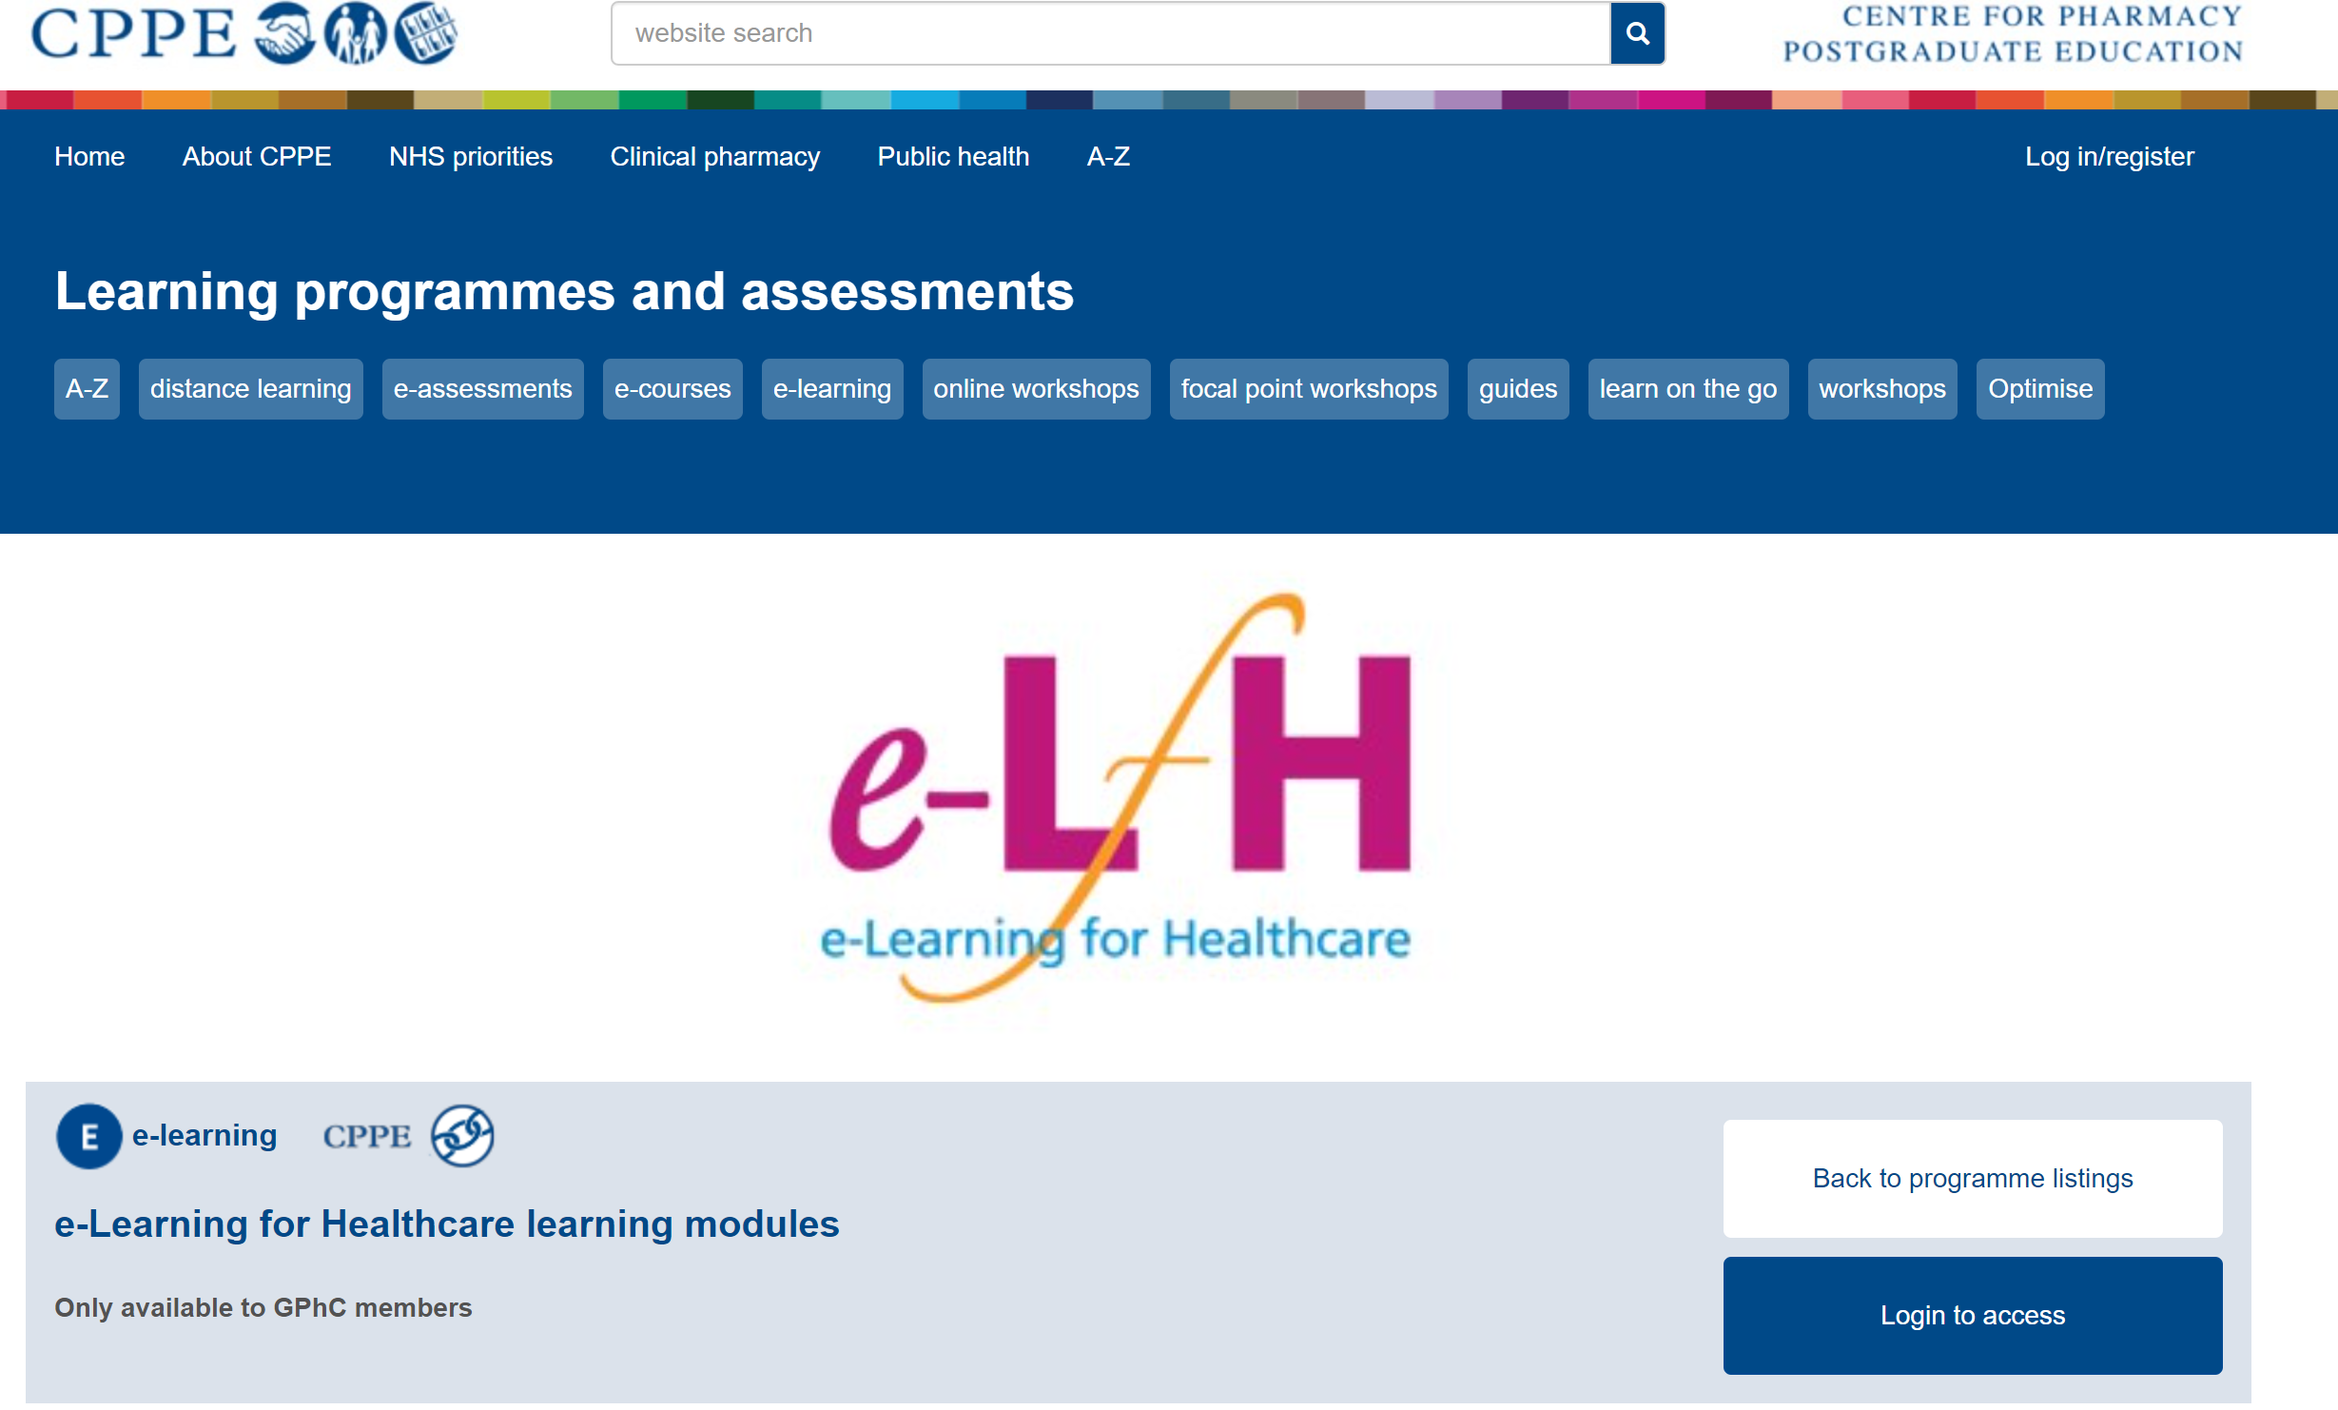

Enrol on to the program and complete the relevant e-learning that you are required to. Once you have done this, you should be able to access your certificates of completed learning, which you will need to present on the first day/ during your placement. These can be printed or presented electronically. You may wish to write reflective account/ evidence on the completed module and save the certificate in your portfolio or upload to your HEE e-portfolio or under ‘Miscellaneous Evidence Upload’.
Please be aware each module may take some time to complete, so allow yourself plenty of time to complete them before/ during your placement.

END

